**Iowa BB2 Model – User’s manual**

Iowa BB2 HDM is a hydrodynamic model of Joubert BB2 (Carrica et al, 2020), a notional submarine geometry developed by DSTO (Australia) and MARIN (The Netherlands). Iowa BB2 HDM was developed at The University of Iowa based on the reduced order model of Gertler and Hagen (1969), adapted to consider a X-shape stern plane arrangement instead of the original cruciform one. The model consists of the full six-Degree-of-Freedom (6DoF) equations of motions for a rigid body, which is solved using discrete time step integration. Controllers are provided including pre-settings for several maneuvers, as described in the accompanying tutorials. The model requires commercial software MatlabTM and SimulinkTM (version 2018a or higher). All required files for the model can be found in <https://github.com/caslabuiowa/IowaBB2model>

The equations of motion are solved in a non-inertial coordinate system solidary with the body as shown in Figure 1, resulting in inertial coupling forces to be added to the system. The general equation of the body is

|  |  |
| --- | --- |
| $$M∙\dot{s}=F-b$$ | (1) |

where *M* is the mass matrix, $s$ is the generalized velocity state vector, $F$ is the external force vector, and $b$ is the inertial coupling vector:

|  |  |
| --- | --- |
| $$M=\left[\begin{matrix}m & 0 & 0 & 0 & mz_{G} & -my_{G} \\ 0 & m & 0 & -mz_{G} & 0 & mx_{G} \\ 0 & 0 & m & my_{G} & -mx_{G} & 0 \\ 0 & -mz_{G} & my_{G} & I_{xx} & -I_{xy} & -I_{xz} \\ mz_{G} & 0 & -mx_{G} & -I_{xy} & I_{yy} & -I_{yz} \\ -my_{G} & mz_{G} & 0 & -I_{xz} & -I_{yz} & I_{zz}\end{matrix}\right]$$ | (2) |

|  |  |
| --- | --- |
|  | (3) |
| $$F=\left[\begin{aligned}-\left(W-B\right)\sin{θ}+X_{H}\left(t,u,\dot{u}\right) \\ \left(W-B\right)\cos{θ}\sin{ϕ}+Y_{H}\left(t,u,\dot{u}\right) \\ \left(W-B\right)\cos{θ}\cos{ϕ}+Z_{H}\left(t,u,\dot{u}\right) \\ \left(y_{G}W-y_{B}B\right)\cos{θ}\cos{ϕ}-\left(z_{G}W-z_{B}W\right)\cos{θ}\sin{ϕ}+K_{H}\left(t,u,\dot{u}\right) \\ -\left(x_{G}W-x_{B}B\right)\cos{θ}\cos{ϕ}-\left(z_{G}W-z_{B}B\right)\sin{θ}+M_{H}\left(t,u,\dot{u}\right) \\ -\left(x_{G}W-x_{B}B\right)\cos{θ}\sin{ϕ}+\left(y_{G}W-y_{B}B\right)\sin{θ}+N_{H}\left(t,u,\dot{u}\right)\end{aligned}\right]$$ | (4) |
|  |  |
| $$b=\left[\begin{aligned}m\left[wq-vr-x_{G}\left(q^{2}+r^{2}\right)+y_{G}\left(pq-\dot{r}\right)+z_{G}\left(pr+\dot{q}\right)\right] \\ m\left[ur-wp-y_{G}\left(r^{2}+p^{2}\right)+z_{G}\left(qr-\dot{p}\right)+x_{G}\left(qp+\dot{r}\right)\right] \\ m\left[vp-uq-z_{G}\left(p^{2}+q^{2}\right)+x_{G}\left(rp-\dot{q}\right)+y_{G}\left(rq+\dot{p}\right)\right] \\ \left(I_{z}-I_{y}\right)qr+m\left[y_{G}\left(\dot{w}-uq+vp\right)-z_{G}\left(\dot{v}-wp+ur\right)\right] \\ \left(I_{x}-I_{z}\right)rp+m\left[z_{G}\left(\dot{u}-vr+wq\right)-x_{G}\left(\dot{w}-uq+vp\right)\right] \\ \left(I_{y}-I_{x}\right)pq+m\left[x_{G}\left(\dot{v}-wp+ur\right)-y_{G}\left(\dot{u}-vr+wq\right)\right]\end{aligned}\right]$$ | (5) |

The vehicle mass is *m*, *I* is its moment of inertia tensor, its center of gravity (CG) and buoyancy (CB) are $\left(x_{G},y_{G},z_{G}\right) and \left(x_{B},y_{B},z_{B}\right)$, and $ϕ, θ$ are the roll and pitch angles. The external force vector $F$ consists of hydrodynamic loadings $X_{H}, Y_{H}, Z_{H}, K_{H}, M_{H},$ and $N_{H}$, and the hydrostatic loading due to buoyancy *B* and vehicle weight *W*. The hydrodynamic loadings in (4) are modeled to be independent from the history of motion based on steady state assumption. Detailed description of the modeled forces can be found in Kim et al. (2021). Therefore, the hydrodynamic loadings are computed from the velocity vector $s$ and its time derivative $\dot{s}$ at each time step $t$.

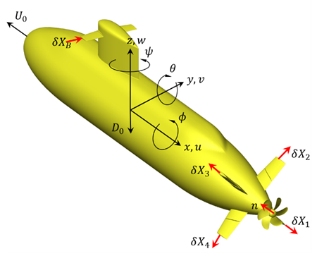

Figure 1: Local coordinate system and appendage axes of rotation.

1. **Numerical set up**

The Iowa Joubert BB2 HDM **Model_6DOF.slx** is the main Simulink file model. In addition to this file, other provided files include: **main.m** which contains the initial state of motion, the main particulars of BB2 such as mass, moment of inertia and the conditions to be simulated; the submarine surface geometry files required for hydrostatic forces and moments computation (provided in folder **surface**); and auxiliary MatlabTM files **import_stl.m** and **load_Surface.m**.

1. **main.m**

The file **main.m** contains the most common variables to be set up by the user to run the model. Further modification by changing the controller or model itself it is possible for advanced users, but not necessary. All variables in **main.m** are required to run the model and are described below.

* 1. Kinematic properties and initial values

The generalized 6-DoF initial position, velocity and acceleration must be provided as vectors, as shown in Table 1. Sea state provides an imposed regular wave defined as having the same mean height and most probable wave frequency as JONSWAP spectra (Lewis, 1989); current implementation does not include full wave spectrum.

Table 1. Variables for setting up the case: kinematic variables and initial values.

|  |  |  |
| --- | --- | --- |
| Physical variable | MATLAB Variable | Notes |
| Vehicle mass and buoyancy | Mb,Bb | In kg. Standard value used is Mb = 4.419e7  Bb = Mb (neutrally buoyant) |
| Moments of Inertia | Ixx, Iyy, Izz, Ixy, Ixz, Iyz | In kg m2. Standard values used are Ixx = 5.23e7; Iyy = 1.375e9; Izz = 1.367e9; and zero for cross terms. |
| Center of rotation | Xg,Yg,Zg | If different from CG, otherwise set to zero. |
| Center of buoyancy | Xb,Yb,Zb | Standard value Zb = 0.4406 m |
| Generalized initial position vector | Bx_0 | Corresponding components are [x, y, z, roll, pitch, yaw] in Earth frame. SI units used. |
| Generalized initial velocity vector | Bv_0 | Corresponding components are [u, v, w,   ] in Ship frame. SI units used. |
| Generalized initial acceleration vector | Ba_0 | SI units used. |
| Initial propeller speed | n_0 | rps |
| Sea-state | Seastate | Sea-state is an integer between 0 and 7. Current implementation imposes a monochromatic wave as described in Table 2 |

Table 2. Wave properties for corresponding sea state values.

|  |  |  |
| --- | --- | --- |
| Sea State | $λ_{s}$ $(m)$ | $H_{s}$ $(m)$ |
| 0-Calm | - | - |
| 2 | 87.8 | 0.3 |
| 3 | 87.8 | 0.88 |
| 4 | 120.9 | 1.88 |
| 5 | 140.9 | 3.25 |
| 6 | 240.1 | 5 |
| 7 | 351.3 | 7.5 |

* 1. Control variables

The Iowa BB2 Model is provided with PID controllers capable of producing several maneuvers, including self-propulsion at different depths in calm water and waves; vertical and horizontal zig-zags; turning circles, and max-q maneuvers. Actuators include the sail planes, the four independent stern planes, trim and ballast tanks. Table 3 summarizes the control options required to set up the different cases, including target values for vehicle speed and other controllable variables.

Table 3. Variables for setting up the case: control variables.

|  |  |  |
| --- | --- | --- |
| Numerical variable | MATLAB Variable | Notes |
| Maneuver switch | m_switch | 0-Self-Propulsion  1-Vertical Zigzag (VZZ)  2-Horizontal Zigzag (HZZ)  3-Turning Circle  4-Maximum Pitch Rate, q. |
| Cruise control switch | n_switch | 0-Imposed rps (n_imposed)  1-Speed Control |
| Imposed rps | n_imposed | In rps |
| Target speed | Usp | In m/s. Note that forward speed is negative due to coordinate system choice |
| Target depth, sway, pitch, yaw | target_z  target_y  target_pitch  target_yaw | Target values for position of CG (in m) and vehicle attitude (in deg). |
| Sail plane switch | sail_switch | 0-sail angle fixed to neutral position  1-actuated with vertical command. |
| Trim tank switch | LCG_switch | 0-constant CG position  1-controlled (PID controller on pitch) |
| Ballast tank switch | mass_switch | 0-constant mass  1-controlled (PID controller on depth) |
| Zigzag check angle | check_angle | Check angle in degrees for VZZ and HZZ |
| Imposed control surface deflection | dX_imposed | In degrees, required for some maneuvers |
| Geometry output | fwrite | 0-no output  1-stl file output of transformed craft geometry as function of time |
| Output frequency | its | Time between stl exports in seconds |
| Degree of freedom switch | DoF_switch | Integer vector. Activate (1) or deactivate (0) each degree of freedom in Eq. 1 |

* 1. Output variables

Iowa BB2 Model provides the option of generating stl files of the geometry during a maneuver, for visualization purposes. The two relevant variables to obtain this output are presented in Table 4.

Table 4. Output variables.

|  |  |  |
| --- | --- | --- |
| Output frequency | its | Time between stl exports in seconds |
| Degree of freedom switch | DoF_switch | Integer vector. Activate (1) or deactivate (0) each degree of freedom in Eq. 1 |

1. **Model_6DOF.slx**

At its highest level, the model consists of two main interacting blocks: a controller block and the HDM itself. Auxiliary elements in Fig. 2 provide scope modules for result visualization. The HDM provides updated generalized 6DoF positions (Bx) and velocities (Bv), based on four sets of controlled parameters: actuation of the control surfaces dX (deflection angle of the sail plane and four independently actuated stern planes); propeller rotational speed n; change in longitudinal location of the center of gravity dLCG (corresponding to the actuation of trim tanks), change in mass dmass (corresponding to the actuation of a ballast tank). An additional variable z_eff provides the vertical distance of the CG to the surface, to be used in the controller rather than the absolute depth in cases with waves.

Each of these blocks can be expanded to reveal its components. Main settings are imposed in **main.m** as previously described, other settings can be modified within the blocks to change controller settings or even the HDM, however this is not necessary to use the model.

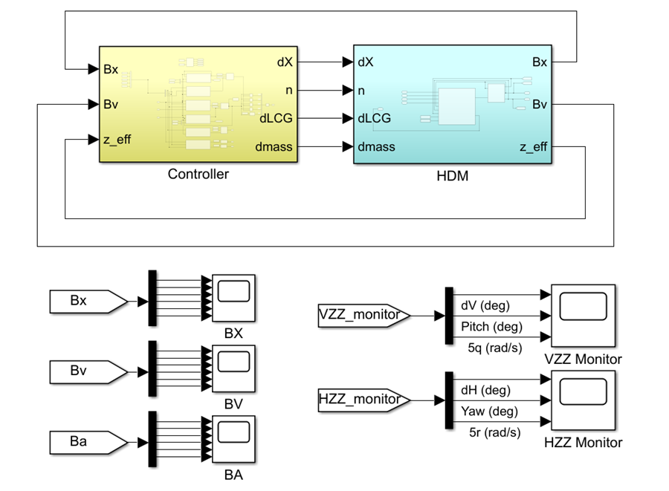

Figure 2. Highest level block diagram of BB2 Simulink Model **Model_6DOF.slx**.

1. **Credits**

This work was partially supported by the US Office of Naval Research through grant N00014-19-2106, Dr. Peter Chang program officer. For in-depth details on the mathematical model the reader is referred to Kim et al. (2021). For further questions on the model and its implementation, please contact Ezequiel Martin (juan-martin@uiowa.edu) or Venanzio Cichella (venanzio-cichella@uiowa.edu ).

1. **References**

Carrica, P.M., Kerkvliet, M., Quadvlieg, F., Matin, J.E., “CFD Simulations and Experiments of a Submarine in Turn, Zigzag, and Surfacing Maneuvers,” Journal of Ship Research, Vol. 64, pp. 1-16, 2020.

Gertler, M. and Hagen G.R., “Standard Equations of Motion for Submarine Simulation,” DTIC Document, Tech. Rep., 1967.

Kim, Y, Martin, J.E., Rober, N., Cichella, V., Carrica, P.M., “A dynamic maneuvering model for the Joubert BB2 submarine in calm water and waves,” in preparation for *Ocean Engineering*, 2021.

Lewis E.V., “Principles of naval architecture second revision,” SNAME, 1988.